NAME: S. DHARANI
REG NO:192472364
COURSE CODE: DSA0401
NUMPY ANALYSIS – QUESTIONS AND ANSWERS
QUESTION 1: STUDENT PERFORMANCE ANALYSIS
AIM:
To calculate the average marks of each subject and identify the subject with the highest average score using NumPy.
ALGORITHM:
- Import the NumPy library.
- Create a 4×4 array containing the marks of four students in four subjects.
- Calculate the average marks of each subject using np.mean() with axis=0.
- Use np.argmax() to find the index of the highest average.
- Display the average marks and the subject with the highest average.
CODE:
import numpy as np
student_scores = np.array([
[85, 90, 78, 88],
[92, 85, 80, 90],
[78, 88, 92, 84],
[88, 92, 85, 86]
])
averages = np.mean(student_scores, axis=0)
subjects = ["Math", "Science", "English", "History"]
for i in range(4):
print(subjects[i], "Average:", averages[i])
highest_index = np.argmax(averages)
print("Highest average subject:", subjects[highest_index])
print("Highest average score:", averages[highest_index])
INPUT:
[[85, 90, 78, 88],
[92, 85, 80, 90],
[78, 88, 92, 84],
[88, 92, 85, 86]]
OUTPUT:
Math Average: 85.75
Science Average: 88.75
English Average: 83.75
History Average: 87.0
Highest average subject: Science
Highest average score: 88.75
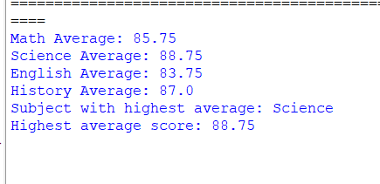
RESULT:
The average marks of all four subjects were calculated successfully. Science has the highest average score of 88.75 marks.

